Ex:No:17

Date:

**TRIGGER**

**Aim:**

To implement trigger in MySQL.

A trigger or database trigger is a stored program executed automatically to respond to a specific event e.g., insert, update or delete occurred in a table.

**Create trigger syntax**

CREATE TRIGGER trigger_nametrigger_timetrigger_event

ON table_name

FOR EACH ROW

BEGIN

...

END;

**Program 1 :**

Create a trigger in MySQL to log the changes of the EMPLOYEES table with fields ID, Name and Email. Also create a new table named EMPLOYEES_AUDIT to keep the changes of the employee table. Create a BEFORE UPDATE trigger that is invoked before a change is made to the employees table.

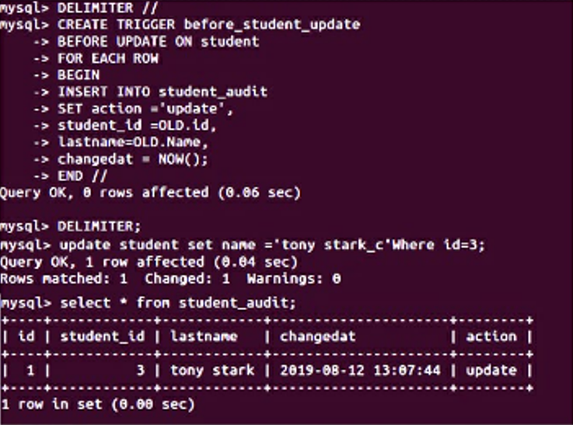

**RESULT:** Thus the trigger is executed successfully.